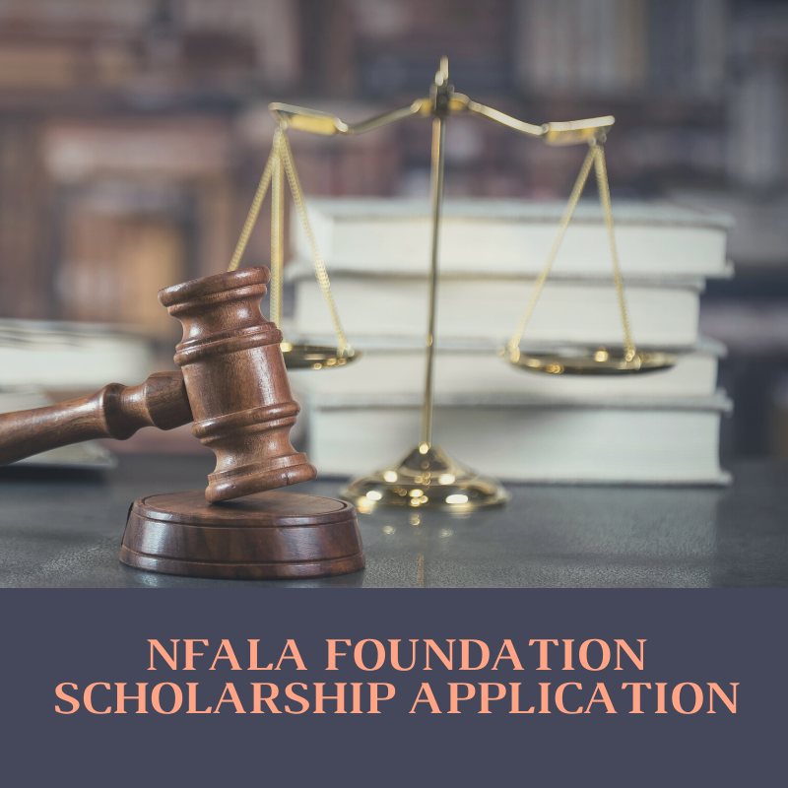
APPLICATIONS DUE 5:00 P.M. (Eastern) MAY 20, 2022

THE ROBIN MANGASER TIZON MEMORIAL LAW SCHOLARSHIP

The Robin Mangaser Tizon Memorial Law Scholarship is sponsored by the NFALA Foundation in collaboration with FALA New York. Robin Mangaser Tizon, Esq., MBA, was a beloved wife, daughter, sister and proud Filipina-American lawyer. Robin was born the third of four daughters, whose immigrant parents instilled in their children the value of education and service to one’s community. Throughout her life, Robin devoted herself in advocacy of many causes, including Filipino veterans’ rights, adolescents with cancer, and immigrants’ rights. She also had musical talent and a fine eye for design, enlivening any event with her singing, dancing, and keyboard skills.

After overcoming stage III ovarian cancer at the age of 23, Robin achieved her dream of becoming a lawyer, graduating from Rutgers School of Law-Camden in 2013 with a JD/MBA degree. Robin focused her practice on intellectual property law. She served as a valuable leader of NFALA and FALA New York where she found inspiring mentors and lifelong friendships. Indeed, as one of the first members and original Co-Chair of the Public Relations Committee since FALA New York’s inception, Robin was instrumental in establishing the FALA New York brand and lasting communications strategy. Throughout her long battle with cancer, Robin remained committed to her duties at FALA New York.

OVERVIEW

NFALA Foundation scholarship awards are given to law students who demonstrate exceptional aptitude for the study of law and strong commitment to serve or contribute to the Filipino-American community as future leaders in the legal profession. The Robin Mangazer Tizon Memorial Law Scholarship was established to honor Robin’s memory and support talented law students who embody her spirit and commitment to service. Each scholarship recipient will receive $800 to $1,000, depending on the number of recipients selected in a given year.

ELIGIBILITY

NFALA Foundation scholarships are made available, on a competitive basis, to students who are enrolled in their Juris Doctor (J.D.), Master of Laws (LL.M.), or Doctor of Juridical Science (S.J.D.) at an accredited U.S. law school (Fall 2022 first time enrollees should submit a statement from your law school certifying that you are a law degree candidate enrolled at least part-time).

The NFALA Foundation strongly encourages applications from applicants reflecting diverse cultural and experiential backgrounds, people with disabilities and of diverse ethnic, racial, religious, and socioeconomic backgrounds, work experiences, national origins, sexual orientations and ages.

CRITERIA
The Robin Mangaser Tizon Memorial Law Scholarship is awarded on the basis of:

- Essay;
- Resume;
- Two (2) letters for recommendation (from persons not related to you);
- Official or unofficial copies of your law school transcript (or for an incoming first-year law student, proof of enrollment); and
- Any further submission showcasing the applicant’s creative talents, particularly in the field of visual arts or music (optional).

IMPORTANT DATES

April 15, 2022 The scholarship application is available
May 20, 2022 The application and supporting materials must be received by 5:00 PM Eastern Time

June 1, 2022 Scholarship Awardee is notified by this date
TBD Scholarship presentation at the FALA NY annual dinner to be held in June.

INSTRUCTIONS
You may apply for the Robin Mangaser Tizon Memorial Law Scholarship by emailing a completed application (enclosed), along with supporting documents listed under Criteria, to RobinMangaserTizonScholarship@gmail.com by 5:00 P.M. (Eastern) on May 15, 2022. Applications must be submitted in one PDF file with the title “Robin Mangaser Tizon Scholarship Application – [Applicant Name]” that consists of all application materials.

Your essay should be no longer than 500 words. Of all the parts of the application, your essay carries the greatest weight. Please emphasize any experience you have that shows your commitment to serving the Filipino- American community, as well as your need for financial assistance.
Please submit two letters of recommendation (recommendation letters for law school admission or other programs and positions are acceptable). It is not necessary to submit more than two recommendation letters. If you submit more than two letters, the committee may only review the first two letters received. Letters may be sealed or unsealed and sent directly by the recommender or by the applicant. An application is not excluded from consideration if no letter of recommendation is provided, though it is highly recommended.
Creative submissions are optional only, but provide the applicant an opportunity to showcase creative talents. Applicants may either a) submit a link to RobinMangaserTizonScholarship@gmail.com with the content showcasing the applicant’s creative talents and provide any necessary permissions to view, or b) request an FTP link via that email for the applicant to upload materials. All creative works must be the applicant’s original work or composition, with recordings of performances or music compositions being no longer than five minutes and a maximum of 5 images (.jpg, .png, etc.) or original written works (maximum of 500 words).

Please email RobinMangaserTizonScholarship@gmail.com with any questions.
2022 APPLICATION

Full Name: ___________________________________________________________________
Mailing Address: _____________________________________________________________

______________________________________________________________________________

Phone Number: ______________________________________________________________

Email Address: _______________________________________________________________

Law School: _________________________________________________________________

Year in Law School: __________________________________________________________

Expected Year of Graduation: ________________________________________________

Relevant Community Involvement
and/or Organization Membership/Leadership:

______________________________________________________________________________

______________________________________________________________________________

______________________________________________________________________________

Law School Scholarships/Awards Received (Provide Names and Dates):

______________________________________________________________________________

______________________________________________________________________________

______________________________________________________________________________

I certify that the contents of my application to be true and correct and that I meet the eligibility requirements of the scholarship.

Signature: ___________________________________________________________________

Date: ___________________________________________________________

ESSAY TOPIC
In light of various challenging events, including the COVID-19 pandemic, escalating racial tensions and anti-AAPI (Asian American Pacific Islander) hate, the Philippine national elections, suppression of media, and global conflict, what are some of the difficulties that you have encountered (including financial need), how have you overcome them, and how have you helped others or show commitment to the Filipino-American community and/or historically underserved communities in New York, New Jersey and/or Pennsylvania? Kindly provide the word count at the end of your essay.

NFALA Foundation is a nonprofit 501(c)(3) tax-exempt charitable organization.
Priority consideration will be given to applicants with a demonstrated commitment and/or experience in serving the Filipino-American community in metropolitan New York, New Jersey and/or Pennsylvania, which are communities that Robin lived in and/or strongly supported. Commitment can be demonstrated both in and outside of the legal profession (e.g., volunteer activities or pro bono work).

